Dear Applicant:

Thank you for considering employment with CDM Caregiving Services. In order to assist you in making an informed decision about our ability to meet your employment needs and expectations, please carefully review the following information before completing this application. It is our hope that individuals completing our application for employment have considered the purpose, the mission and the vision of CDM Caregiving Services before deciding to seek employment with this organization. It is our goal to employ individuals committed to helping others remain independent at home through a commitment to our company goals and ideals.

If you have any questions, or need additional information please ask any member of our staff. Again, thank you for considering CDM Caregiving Services.

EMPLOYMENT INFORMATION
- Mission:
To provide services that allows individuals to live with dignity in their home or residence.
CDM Caregiving Services’ goal is to improve the quality of life of those we serve. We train our employees to be reliable and confident, and to display a dedication to quality and caring commitment to the elderly and disabled.

- Position:
Home Care Specialist

- Duties:
Provide assistance with daily tasks. Please see job description and list of tasks included with application materials.

- Location:
Private homes of clients in Clark County.

- Wages:
$13.85 to start. 25¢ per hour weekend pay differential, $1.00 per hour Hoyer pay differential. Mileage reimbursement (when applicable) 50¢ per mile.

- Benefits:
-Medical dental and vision benefits available.
-Paid time off
-AFLAC insurance programs
-Retirement Plan.

Pre-employment drug testing may be required

HOME CARE SPECIALIST JOB DESCRIPTION

Provides the tasks each client is authorized to receive within each program’s guidelines.

FEEDING OR EATING
Cut up cooked food for the client. Take food to the client. Butter toast, pancakes, etc .Spoon feed client. Cue client to feed self
Encourage liquids. Keep liquids available

TOILET USE (use disposable latex gloves)
Help the client to and from the bathroom. Help the client on or off the toilet or commode. Clean up when the client is incontinent Empty and clean urinal, commode or bedpan (1 part bleach/ 10 parts water. ) Change and dispose of protective undergarments/incontinence pads (i.e. Depends or Chuks Pads) Assist incontinent client with protective undergarments/incontinence pads (i.e. Depends or Chuks Pads) Remind the client (timed toileting) Empty catheter bag. Assist client to change a colostomy bag. Adjust client’s clothing

AMBULATION/LOCOMOTION
Provide support and steadying. Assist client to walk. Hold on to client’s arm. Push client while in wheelchair. Give cane or walker to the client. Escort client. Keep walkways clear of clutter. Make sure client wears shoes/slippers

TRANSFER
Assist the client in moving to/from bed, chair, wheelchair, standing position without lifting (use transfer device if needed.) All specialists involved in any form of transfer MUST wear a back brace

POSITIONING/BED MOBILITY
Turning bed bound patients. Prop pillows. Positioning a client comfortably in a wheelchair

SPECIALIZED BODY CARE
Apply non-prescription lotion/ointments to body, but do not apply it between the toes. Passive Range of Motion exercises. Application of dry bandages. Skin Care including nutrition/hydration, preventative/protective care (to be described on client plan of care)Soak/clean nails. File and clip client’s fingernails and toenails. File/clip toenails straight across. Ingrown nails or problem nails should be treated by a podiatrist (medical coupons can be used).

CARE OF APPEARANCE / PERSONAL HYGIENE
Comb and brush the client’s hair. Set the client’s hair. Brush client’s teeth. Clean the client’s dentures - oral hygiene (use disposable latex gloves)Shave with electric razor preferably. If using disposable razor, use latex gloves. Applying makeup. Washing/drying face, hands and perineum. Take the client to a beauty or barber shop for haircuts

DRESSING AND UNDRESSING
Fasten and unfasten clothing. Get the clothing out of closet or dresser. Color coordinate client’s clothing. Assist client to put on or take off any item of clothing. Assist client to choose clean/appropriate clothing

BATHING (use disposable latex gloves)
Assist client in/out of the shower. Standby while the client takes a bath. Wash the client’s back, feet, legs, other hard to reach areas. Shampoo client’s hair. Soak and wash the client’s feet. Provide the client with soap, washcloth, and a towel. Assist the client with a sponge bath or bed bath

SELF MEDICATION/MEDICATION MANAGEMENT (WASHINGTON ONLY)
Document administration. Open medisets/bottles. Hand medication in cup or bowl. Read labels to client. Re-order medications. Report adverse reactions. Remind the client to take medication. Monitor medications - check medisets/bottles

MEAL PREPARATION
For safe food preparation/storage techniques, please refer to Food & Beverage Workers’ Card Manual (located in back of this. manual.)Prepare meals as requested by the client. Encourage the client to eat, following proper nutrition. Prepare food for the client to cook ( peel or cut up vegetables and fruits)Prepare meals ahead of time for client to defrost/reheat. Put dishes in the dishwasher, or wash by hand (use rubber gloves) Clean kitchen after each meal.

HOUSEWORK/LAUNDRY
Wash clothing, towels, and bed linens, but never by hand (use disposable gloves) Change bed linens (use disposable gloves)Do laundry at client’s home or a Laundromat (use disposable gloves)Iron clothing if needed. Mend clothing, sew on buttons, but no alterations. Dry clothing, linen, and towels. May hang laundry to air dry (inside or outside), old laundry, and put it away. Routine housework includes vacuuming, dusting, sweeping/mopping floors, taking out garbage, making bed, and cleaning all bathroom and kitchen surfaces. Wash cupboards, door handles, switch plates, spots on the walls, etc. Clean kitchen after each meal. Clean refrigerator and stove. Clean toilet - use long handled brush and rubber gloves. Clean the oven at least twice a year or as needed. Defrost freezer if ½″ of ice is present. Dust, moving large items (lamps, bowls, ashtrays, etc.).

TELEPHONE USE
Answer phone for client. Dial telephone for client. Make calls for client. Take messages for client

TRANSPORTATION

Take client to and from the doctor appointments (as a means of last resort) Pick up the client from the hospital or take to the hospital for tests. Take the client to pick up prescribed medications or attain refills/medisets prepared by Pharmacist Accompany the client on C-Van or in an ambulance. Stay with the client at the doctor’s office. Home Care Specialists can assist with finding alternate transportation if needed

SHOPPING
Pay Bills. Get prescribed medications. Shop for clothing. Do banking. Grocery shop (encourage nutritional choices)Trip to the post office. Pick up mail. Christmas shopping

WOOD SUPPLY (IF CLIENT’S ONLY SOURCE OF HEAT)
Bring wood into the client’s home. Burn wood

SUPERVISION (If Authorized)
Cueing the client when memory impaired. Providing cognitive support. Providing unscheduled tasks. Remain with a client to ensure their safety when all other tasks are compete

Additionally – All HCS’s Must:

- Observe clients general mental and physical condition report changes to the Client Care Coordinator.

- Practices safety and competency. Including ability to respond appropriately to an emergency situation.

- Submit monthly schedules and report any schedule changes to the Home Care Supervisor.

- Complete neat and accurate records of tasks performed during each scheduled visit.

- Provides healthy, safe environment for the client.

- Provide all authorized tasks and hours assigned.

- Attend all required training.

I have read and understand the job description and I am able to perform each task listed.

Signature Date

APPLICATION FOR EMPLOYMENT

We consider applicants for all positions without regard to a person’s race, color, creed, religion, national origin, sex (including pregnancy), age (40+), sexual orientation, marital status, families with children, veteran or military status, the presence of any sensory, mental or physical disability (including HIV, AIDS, hepatitis C status) or the use of a service animal or guide dog, genetic information, or any other status or characteristic protected under any applicable federal or state law. WE ARE AN EQUAL OPPORTUNITY EMPLOYER

(PLEASE PRINT)
Position(s) Applied for Date of Application

Last name First Name Middle Name

Address: Number Street City State Zip Code

Telephone Number Cellular Number Birth Date Social Security #
- -

E-mail____________________________________

Emergency Contact________________________________________Phone____________________________

Have you ever filed an application with us before Yes_______ No_______

Have you been employed with us before? Yes_____ No_______ Dates: ______________

Are you currently employed?_______________________

May we contact your present employer? Yes_________ No_________

Are you prevented from lawfully becoming employed in this country because of Visa or Immigration Status? (Proof of citizenship or immigration status will be required upon employment.)Yes__________No__________

On what date would you be available for work?___________________________

Are you currently on “lay-off” status and subject to recall? Yes_____ No _____

Are you a Veteran? Yes_________ If yes what branch?___________________ No_____
EDUCATION

Name & Address Course Study Years Completed Diploma
of School Degree

High School

Undergraduate College

Graduate Professional

Other

INDICATE ANY LANGUAGES YOU CAN SPEAK/READ/WRITE/SIGN

Fluent Good Fair

Speak____________________________________________________________________________________
Read_____________________________________________________________________________________
Write_____________________________________________________________________________________
Sign______________________________________________________________________________________

PLEASE INDICATE ANY SPECIALIZED TRAINING OR EXPERIENCE

CPR______________________________________________________________________________________
CNA_____________________________________________________________________________________
R.N.______________________________________________________________________________________
L.P.N_____________________________________________________________________________________
FIRST AID________________________________________________________________________________

NURSING HOME EXPERIENCE______________________________________________________________

FUNDAMENTALS OF CAREGIVING_________________________________________________________

OTHER QUALIFICATIONS
Summarize special job-related skills and qualification acquired from life experience or volunteer work

___________________________________________________________________________________________________________________________________________________________________________________

EMPLOYMENT EXPERIENCE Start with your present or last job. Include any job-related military service assignments & volunteer activities. You may exclude organizations which indicate race, color, religion, gender, national origin, disabilities or other protected status.

Employer Employed From/To Work Performed

Address

Telephone Salary-Beg/End

Job Title Supervisor

Reason for Leaving

Employer Employed From/To Work Performed

Address

Telephone Salary-Beg/End

Job Title Supervisor

Reason for Leaving

Employer Employed From/To Work Performed

Address

Telephone Salary-Beg/End

Job Title Supervisor

Reason for Leaving

Employer Employed From/To Work Performed

Address

Telephone Salary-Beg/End

Job Title Supervisor
Reason for Leaving

ADDITONAL INFORMATION

Please list any additional skills you would like us to know about.

__________________________________________________________________________________________

REFERENCES-NO RELATIVES PLEASE

- _____________________________________________________( ____)_________________________
Name Phone

2. ______________________________________________________( )________________________
Name Phone

3. _______________________________________________________(____)________________________
Name Phone

Recruitment Survey:

We are interested in how you first found out about us. Please indicate below the resource you used.

__________State Unemployment Office ________Web Page

__________Newspaper Ad________________________ ________Walk In
Name of Publication

__________Employee Referral_____________________ _________Job Fair_________________
Name of Employee Please Specify

__________School_______________________________ __________Other___________________
Name of Institution Please Specify

PRE-HIRE INTERVIEW CHECKLIST

PLEASE INITIAL EACH

______ Beginning January 7, 2012 any person hired as a long-term care worker must be certified as a Home Care Aide.
This includes the following:
- Submit to a state and federal background check through DSHS.
- Within 14 days of hire, submit the home care aide certification application.
- Within 200 days of hire, complete 75 hours of DSHS approved Basic Training and pass the DOH HCA examination.
You are exempt from certification if you were already employed as a long-term care worker between January 1, 2011 and January 6, 2012 and completed all of the training requirements in effect as of the date you were hired.

___1. C.D.M. is an equal opportunity employer.

___2. CDM is a private non-profit agency incorporated in the State of Washington. We provide service to low-income, seniors and others with disabilities in Clark County. Our purpose is to keep seniors and the disabled in their own homes with assistance and out of nursing home placement as long as possible.
___3. You must have an employment eligibility document, valid Washington ID, and be 18 years of age or older. If you use your own vehicle while employed at CDM, you must have a current driver’s license (Washington or Oregon) and proof of current auto insurance, without this you may not use your vehicle to conduct any CDM business including transporting clients.

___4. You are required to sign the following: Oath of Confidentiality, Workplace Policy on Drug & Alcohol Abuse, Request for Criminal History Information (abuse), and Request for Abstract of Driving Record.

___5. Initiative 1163 requires that ALL LTC workers, newly hired on or after January 2, 2012, have a Washington State name and DOB and FBI fingerprint-based background check regardless of how long the worker has lived in Washington State.
___6. All employees are paid bi-monthly. Paydays will usually fall on the on the 7th and the 21st. If payday (the 7th) falls on a Saturday, employees will be paid on Friday the 6th, if payday falls on a Sunday, employees will be paid on the 8th. In the event that a Federal Reserve Holiday occurs during the first seven days of the month (i.e. Labor Day on a Monday the 7th), employees will be paid on the 8th. The same rules apply to the 21st pay date regarding Federal Reserve Holidays in the preceding week, and when the 21st falls on a weekend.

___7. You must complete all training as explained in the interview process.

___8. C.D.M. promotes from the ranks when possible.

___9. You are employed on a trial basis for three full calendar months.

___10. Punctuality and dependability are a must! Work is expected to be performed according to a scheduled time for each client.

___11. Authorized and approved mileage and travel time is paid between clients.

___12. Benefits include:
- Workman’s Compensation plus unemployment benefits;
- Medical, dental and vision insurance;
- Retirement plan for qualified employees;
- Vacation pay accrual dependent upon hours worked; available for cash out after 6 months of employment

___13.TB testing may be required.

___14.You are required to work eighty (80) hours per month to qualify for benefits.

___15.All employees must attend all required trainings including 12 hours of continuing education each year following the year they complete basic training.

Applicants Signature

Reference Check Authorization and Release

I have applied for employment with CDM Caregiving Services. All information that I provided during the course of the application process is complete and accurate to the best of my knowledge. I understand that misrepresentations or omissions are grounds for rejection of my application or dismissal from employment if discovered after my employment begins.

I understand that a reference check is part of the application process. I request and authorize CDM Caregiving Services, for purposes of a reference check, to contact the school officials, former employers and personal references I have named during the course of my application for employment, as well as anyone else (including government agencies) who can provide information about my background, employment history and job qualifications.

I agree that the reference check may cover any job-related information, including, but not limited to, the items listed below:

1. Dates of employment or school attendance.
2. Skills, training and education.
3. Possession of required licenses and certificates, including any suspensions or revocations (past or current).
4. Work history.
5. Job duties, including types of equipment operated and responsibility for money or valuables.
6. Quality and quantity of work performance.
7. Work safety, including unsafe acts that resulted in near misses, property damage or injury.
8. Reasons for leaving the company or school.
9. Whether my conduct was generally satisfactory.
10. Character, civil records and criminal history.

I agree to hold harmless and to waive any and all claims I may have against CDM Caregiving Services and its agents and employees for any and all loss or injury I may sustain as a result of CDM Caregiving Services investigating my background in accordance with this release. I also agree to hold harmless and to waive any and all claims I may have against the entities, individuals, agents and employees who provide information to CDM Caregiving Services in connection with CDM’s investigation of my background, for any and all loss or injury I may sustain as a result of any disclosure made in accordance with this release. I understand that this includes the possible rejection of my application for employment.

I have received a copy of this authorization and release, understand it and have had an opportunity to ask questions and obtain answers to my questions.

________________________________________________
Applicant’s printed name

Applicant’s Signature Date

Availability Agreement

I am applying for employment with CDM Caregiving Services with the express understanding that I will be available and willing to work the days/shifts I have indicated below. I understand that misrepresentation of my availability may result in the withdrawal of the offer of employment by CDM Caregiving Services.

Please list specific times you are available to work.
- Please Identify “am” or “pm.”
- If available any time writing “any” is acceptable.
- If unavailable please mark “x” in the box.

I am available and willing to work:

 | Sun | Mon | Tues | Wed | Thurs | Fri | Sat

Start Time:

*Example: 9AM

End Time:

*Example: 10PM
Overnight?
Yes or No?

How many hours per week would you prefer to work? ___________

Please note any exceptions or additional information regarding your availability:
__________________________________________________________________
__________________________________________________________________
__________________________________________________________________
__________________________________________________________________

Applicant Printed Name

Applicant Signature Date

Every employee IS REQUIRED to provide personal care for both Men and Women

Additional Information
This information will be used to determine if we have clients available that suit your preferences. None of the following information will necessarily be disqualifying. In some instances training is provided, feel free to note “Would like training.” DO NOT LEAVE BLANK

CDM provides services to Clark County. We have clients in all Vancouver areas.
Camas; Washougal; Battleground; Yacolt; Amboy; Ridgefield; La Center and Woodland

Where are you willing to work on a permanent basis?
____________________________________________________________________________________________________________________________________________________________________________________________________ Where are you willing to work on a occasional basis?
____________________________________________________________________________________________________________________________________________________________________________________________________

Do you have a valid Driver’s License? ___________
Which State is it issued in? _____________________
Do you have your own vehicle? __________________
Is your vehicle insured? _________________________
Vehicle make and model: _________________________

Do you smoke? _______

Are you willing to work in the homes of people who smoke?___________
Are you willing to work for people who have pets?__________________
Are you willing to work in the home of a woman?__________________
Are you willing to work in the home of a man?____________________

Will you do personal care tasks like assisting with bathing and toileting?
For a man?__________ For a woman?__________

Do you know what a Hoyer Lift is?_____________________________________
Do you have experience using a Hoyer Lift?_______________________________
Do you have other transfer experience?____________________________________
What type of transfers to you have experience with?__________________________________________

Are you willing to work with Children? ____________

Do you have any knowledge/experience working with Autistic behaviors? Please Explain:
____________________________________________________________________________________
____________________________________________________________________________________

Do you have any knowledge/experience working with Mental Illness? Please Explain:
____________________________________________________________________________________
____________________________________________________________________________________

Do you have any knowledge/experience working with Dementia/Alzheimer’s? Please Explain:
_____________________________________________________________________________________
_____________________________________________________________________________________

Do you have any knowledge/experience working with Developmentally Disabled adults? Please Explain:
_____________________________________________________________________________________
_____________________________________________________________________________________
Applicant’s Statement

I certify the answers given herein are true and complete to the best of my knowledge.

I authorize investigation of all statements contained in the application for employment as may be necessary in arriving at an employment decision.

This application for employment shall be considered active a period of time not to exceed 45 days. Any applicant wishing to be considered for employment beyond this time period should inquire as to whether or not applications are being accepted at that time.

I hereby understand and acknowledge that, unless otherwise defined by applicable law, any employment relationship with this organization is of an “at will” nature, which mean that the Employee may resign at any time and the Employer may at any time discharge Employee at any time with or without cause. It is further understood that this “at will” employment relationship may not be changed by any written document or by conduct unless such change is specifically acknowledged in writing by an authorized executive of this organization.

In the event of employment I understand that false or misleading information or interviews may result in discharge. I understand, also, that I am required to abide by all rules and regulations of the employer.

I hereby understand that I must work at least 20 hours a week and I agree to work (check your choices)

_____Full Time_____Part Time_____Shift Work_____Sleepovers_____Evenings
_____Weekends_____24 hour care_____Temporary.

______________________________________________________________________________
Signature Date

FOR PERSONNEL DEPARTMENT USE ONLY

Arrange Interview: Yes_____ No_____ Interviewed by:_____________________Date_______

Remarks______________________________________________________________________________________________________________________________________________________________________________________________________________________________________________________________________

Employed? Yes______ No_______ Date Hired______________ Hourly Rate/Salary______________

Hired for: Washington__________ Job Title___________________________

Hired by_______________________________________________Date______________________________

Fingerprint-Based Background Check
Notice
Information about your fingerprint-based background check:
- In order to determine a person’s character, competence and suitability to have unsupervised access to vulnerable individuals, the Department of Social and Health Services requires a background check that is based upon the person’s fingerprints. These background checks are required by several state laws, including RCW 43.43.837.
- Your fingerprints will be used to check the criminal history record files that are kept by the Washington State Patrol (WSP) and the Federal Bureau of Investigation (FBI). Once the fingerprint check is complete, you may obtain a copy of your background check result by contacting the Background Check Central Unit at 360-902-0299 or BCCUinquiry@dshs.wa.gov.
- If you believe the results of your background check are not complete or are wrong, you have an opportunity to complete or challenge the accuracy of the information as described below.
  - The background check result letter explains how to correct information that was provided by the Washington State Patrol, the Washington Courts, the Department of Corrections, or the Department of Health.
  - There are two ways to correct information on the FBI Identification Record:
    - Contact the state or federal agency or agencies that provided the information to the FBI; or
    - Send a written challenge request to the FBI's Criminal Justice Information Services (CJIS) Division by writing to the following address:
FBI CJIS Division
Attention: Correspondence Group
1000 Custer Hollow Road
Clarksburg, WV 26306
Your written request to the FBI should clearly identify the information that you feel is inaccurate or incomplete and should include copies of any available proof or documents that support your claim. For example, if information about what happened to a criminal charge against you is incorrect or missing, you may submit documentation from the court or the office that prosecuted the offense. The Correspondence Group will contact appropriate agencies to try to verify or correct challenged entries for you. When the FBI receives official communication from the agency with jurisdiction over the matter, the FBI will make appropriate changes and notify you of the outcome. (This process is described in 28 C.F.R. § 16.34.)
- The Federal Bureau of Investigation (FBI) Privacy Act Statement is available on the FBI website at http://www.fbi.gov/about-us/cjis/cc/library/privacy-act-statement-1.
By signing this notification I acknowledge that:
I received a copy of this notice because I am required to have a fingerprint-based background check. The person or entity that requested the background check is required to keep a copy of this signed notice for their records and to return the original notice to me. I will be notified of the result of my background check when the person or entity that requested the background check received the final fingerprint result letter.
APPLICANT SIGNATURE DATE |  | PRINTED NAME

 | Background Check Authorization |  |  |  |  |  |  |  |  | PROCESSING CODE  FINGERPRINTS NEEDED
Section 1. Entity Information (Completed by DSHS staff, provider, applicant, licensee, and/or contractor)
1A. ENTITY REQUESTING THE BACKGROUND CHECK  CDM CAREGIVING SERVICES |  |  | 1B. ENTIRE ADDRESS OF ENTITY LISTED IN BOX 1A  2409 BROADWAY ST. VANCOUVER, WA |  |  |  |  |  |  | 1C. NAME OF SECONDARY ENTITY
2. REQUIRED: NAME AND SIGNATURE OF PERSON REQUESTING THE BACKGROUND CHECK
PRINTED NAME: RYAN BOYER SIGNATURE:
3. REQUIRED ONLY FOR DSHS STATE EMPLOYMENT
DSHS POSITION NUMBER (WRITE NONE IF NONE) DSHS JOB CLASSIFICATION: PERSONNEL IDENTIFICATION NUMBER:
Permanent appointment Non-permanent appointment Work study / student internship Volunteer Acting
4. REQUIRED: BCCU ACCOUNT NUMBER  80000207 |  |  |  |  | 5. DSHS ID NUMBER OR NAME
Section 2. This Section is for Applicant Information Only (The person to be checked is the applicant)
6. SOCIAL SECURITY NUMBER |  | 7. REQUIRED: DATE OF BIRTH (MM/DD/YYYY) |  |  |  | 8. PRINT YOUR E-MAIL ADDRESS
9. REQUIRED: PRINT YOUR NAME AS IT IS LISTED ON YOUR DRIVER’S LICENSE OR OTHER PHOTO ID. WRITE N/A IN THE BOX IF YOU DON’T HAVE A NAME TO ENTER.
FIRST: |  |  |  | MIDDLE: |  |  |  | LAST:
10. REQUIRED: PRINT ALL OTHER FIRST, MIDDLE AND LAST NAMES YOU HAVE USED. WRITE N/A IN THE BOX IF YOU DON’T HAVE A NAME TO ENTER.
FIRST: |  |  |  | MIDDLE: |  |  |  | LAST:
REQUIRED: SELF DISCLOSURE QUESTIONS. SEE INSTRUCTIONS.
You must answer Questions 11A through 14. Attach an additional sheet of paper if you need to list additional crimes or pending charges.
11A. Have you been convicted of any crime? If yes, fill in the blanks below. Yes No
Degree: State: Conviction date: / /
11B. Do you have charges (pending) against you for any crime? If yes, fill in the blanks below. Yes No
Degree: State:
12. Has a court or state agency ever issued you an order or other final notification stating that you have sexually
abused, physically abused, neglected, abandoned, or exploited a child, juvenile, or vulnerable adult? Yes No
13. Has a government agency ever denied, terminated, or revoked your contract or license for failing to care for
children, juveniles, or vulnerable adults; or have you ever given up your contract or license because a government
agency was taking action against you for failing to care for children, juveniles, or vulnerable adults? Yes No
14. Has a court ever entered any of the following against you for abuse, sexual abuse, neglect, abandonment,
domestic violence, exploitation, or financial exploitation of a vulnerable adult, juvenile or child? Yes No
- Permanent* vulnerable adult protection order / restraining order, either active or expired, under RCW 74.34.
- Sexual assault protection order under RCW 7.90.
- Permanent* civil anti-harassment protection order, either active or expired, under RCW 10.14.
See instructions for description of “permanent.”
15. REQUIRED: PRINT YOUR DRIVER’S LICENSE OR STATE IDENTIFICATION NUMBER (WRITE NONE IF NONE) |  |  |  |  |  |  | REQUIRED: PRINT THE NAME OF THE STATE ON YOUR LICENSE OR ID
16. REQUIRED
Have you lived in any state or country other than Washington State within the last three years (36 months)? Yes No
17. A. REQUIRED: PRINT YOUR MAILING ADDRESS WHERE WE CAN SEND YOU CONFIDENTIAL INFORMATION
APT. NO. CITY STATE ZIP CODE
B. REQUIRED: PRINT THE STREET ADDRESS WHERE YOU LIVE NOW (WRITE “SAME” IF YOUR STREET ADDRESS IS THE SAME AS YOUR MAILING ADDRESS)
APT. NO. CITY STATE ZIP CODE
C. REQUIRED: GIVE THE DAYTIME AREA CODE AND TELEPHONE NUMBER WHERE YOU CAN BE REACHED

18. I am the person named above. If I do not tell the whole truth on this form, I understand I can be charged with perjury and I may not be allowed to work with vulnerable adults, juveniles or children. I understand and agree my signature in box number 19 means:
- I give DSHS permission to check my background with any governmental entity and law enforcement agency.
- My background check result may include prior self-disclosure information and fingerprint results that are contained in the DSHS Background Check System and that this information will be reported as allowed by federal or state law.
- If a final finding is identified, DSHS will report only my name and that a final finding was identified on the background check result.
- DSHS will give my background check result to the persons or entities named in Section 1 and may release my background check results to other persons or entities when the law authorizes or requires DSHS to do so. Fingerprint rap sheets are provided if allowed by federal or state law.
- The entity requesting this background check must submit this form to the Background Check Central Unit within the timeframe required by the DSHS oversight program.
19. REQUIRED: YOUR SIGNATURE. YOUR PARENT OR GUARDIAN’S SIGNATURE IF YOU ARE UNDER 18. |  |  |  |  |  |  |  |  | 20. REQUIRED: TODAY’S DATE (MM/DD/YYYY)
PROGRAM USE – FOLLOW INSTRUCTIONS PROVIDED BY YOUR DSHS OVERSIGHT PROGRAM
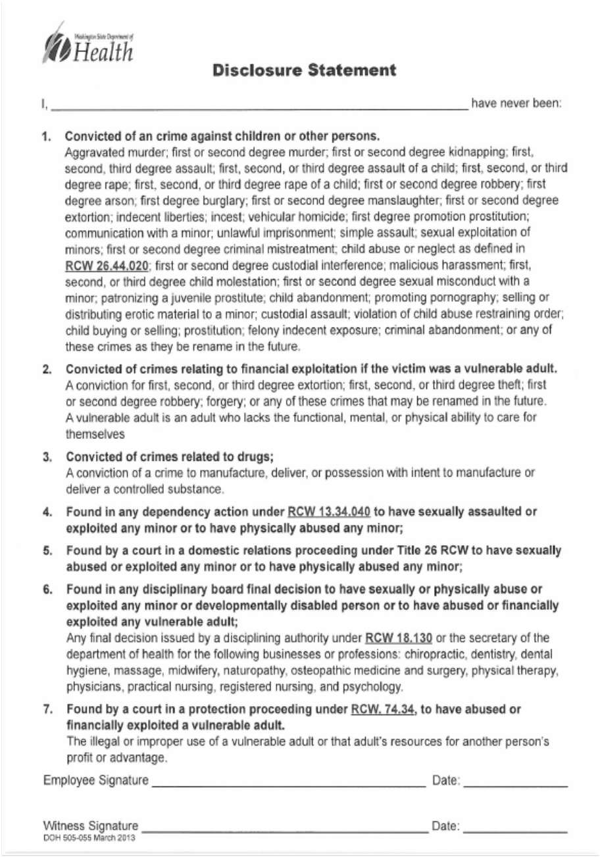

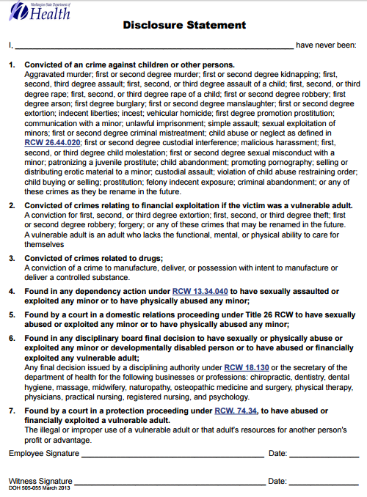

The following information is needed to comply with federal regulations requiring certain employers to track data related to Equal Opportunity and Affirmative Action. The information will be used only in accordance with those laws and regulations and will be kept strictly confidential. This information will be processed separately from you application and any other employment records for this company before being referred to those handling position openings. We are an affirmative action, equal opportunity employer. If you should need accommodation to participate in this application process, please make your need known at this time. Thank you for your assistance.

Last Name_______________________________First Name_____________________Middle Initial______

Social Security Number_______________________________Application Date_______________________

Position Applied For______________________Female___________Male________DOB_______________

Ethnic Information:

______White-a person having origins in Europe, North Africa or the Middle East

_____ Black/African American-A person having origins in any black racial group.

______Hispanic-a person of Mexican, Puerto Rican, Cuban, Central or South American or other Spanish culture or origin, regardless of race.

_____Asian-Refers to people having origins in any of the original peoples of
East Asia, or Southeast Asia including Bangladesh, Cambodia, China, Pakistan, India, Indonesia, Japan, Korea, Malaysia, Philippines, Taiwan, Thailand and Vietnam.

_____Native American-(American Indian or Alaskan Native)-All persons having origins in any of the original peoples of North America and who maintain cultural identification through tribal affiliation or community reception

s:\cdm\human resources\employee handbook\application\hca application jan 2016.docx

